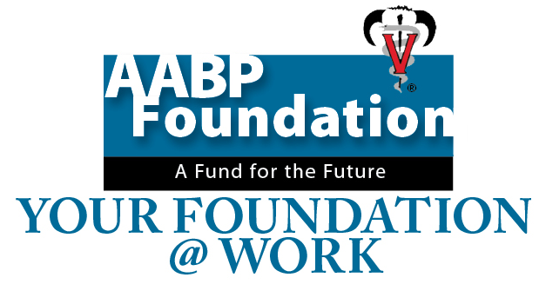

Dr. Edwin Robertson Scholarship Fund

Probably anyone involved in bovine embryo transfer knows the name of Edwin Robertson, DVM, Harrogate Genetics, Int’l, Harrogate, Tenn. Robertson passed away this year in July at the age of 65.
Robertson received his DVM from Auburn University in 1974 and began a career focused on embryo transfer in the Southeast, served as the American Embryo Transfer Association president in 1989-90, and was AABP’s Practitioner of the Year in 1993, among many other activities in organized veterinary medicine. Robertson also coordinated numerous AABP seminars from 1980-2013.
Longtime friend and business partner Sam Edwards, DVM, says Robertson was passionate about furthering education on embryo transfer.
After Robertson passed away, Edwards says he was approached by some people who had money for a scholarship fund, and he thought about a scholarship in Robertson’s name. He contacted AABP and spoke with Dr. Glenn Rogers, chairman of the AABP Foundation Committee about working through the Foundation to establish the scholarship. The funds are designated specifically for veterinary students interested in bovine reproduction at Auburn University or Lincoln Memorial University.
“I immediately thought of an educational scholarship because that’s what Edwin would want,” Edwards explains. “The fund is set up for large animal students who are interested in bovine ET or theriogenology. Edwin’s wife Judy and his family are very much in favor of it and are committed to the fund.”
Rogers says at this point all details have not yet been worked out with regard to selection of applicants and disbursement of funds. The first award will likely be given in 2016
Edwards encourages other AABP members to consider donating to the Foundation or setting up similar scholarship funds through their estates. “It’s really easy to set these things up through the Foundation and you can do what you or the family wants as far as designating the money,” he says. “We’re just waiting to see how much we end up with and if we’ll make an endowment or just give away the money that is contributed.”
Robertson was a passionate person about the things he loved and would have been pleased to see his legacy of education continued, Edwards notes. “He had his priorities in line. The three things that stand out are that he loved his God, his family and veterinary medicine.”
For further information about creating a lasting gift through the AABP Foundation for you or to honor a colleague, contact Dr. Gatz Riddell at mgriddell@aabp.org (800-269-2227) or Dr. Glenn Rogers at beef@aledobb.com (817-319-1239).
Find more Your Foundation @ Work articles at http://foundation.aabp.org/at_work/Your_Foundation_at_Work.asp.

